A longitudinal study examining mental health outcomes by gender for orphaned and separated children in Delhi, India
Sriramkumar Sridharan, Anna Bensley, Jin Huh, and Deepthi Nacharaju

March 20, 2017
¹Duke University, Durham, North Carolina, USA
© 2017 DUKE STUDENT GLOBAL HEALTH REVIEW

(http://dsghreview.com/longitudinal-study-examining-mental-health-outcomes-gender-orphaned-separated-children-delhi-india/)

Previous studies indicate that orphaned and separated children (OSC) tend to report worse mental and physical health outcomes than their non-OSC counterparts. As part of a larger body of work, this longitudinal study evaluated the health outcomes within a population of OSC children living within a residential care program in New Delhi, India. Samples of children were randomly selected from eleven gender specific group homes in 2014 (n=89), 2015 (n=82) and 2016 (n=95) and were interviewed using measures of self-concept, peer and guardian attachment, self-concept, depression, ego-resiliency, and trauma symptoms. Here we specifically report on the gender-based variations in the responses of children who remained in our longitudinal sample over all three years of data collection (n=65). We discovered that females consistently performed, on average, worse than their male counterparts on all measures, but most significantly on measures of trauma and depression. Moreover, the 2016 data suggest at least a slight divergence between male and female scores in trauma, depression, and ego-resiliency scores, indicating that female performance on these tasks is worsening while male performance is improving in the longitudinal sample over time. Additionally, attachment scores across both genders are consistently falling, while depression scores remain above the clinical threshold for risk in both 2015 and 2016.

Background
Due to difficult past histories and the various accompanying challenges of residing in an institution, orphaned and separated children (OSC) living in low- and middle-income countries (LMIC) are considered to be a vulnerable population. OSC face a multitude of potentially traumatic events beyond the loss of a parent (Whetten et al. 2011) that can greatly impact mental health outcomes. Previous research suggests that orphan children exhibit lower self-concept and ego-resiliency, greater levels of historical trauma, and increased anxious or avoidant attachment compared to non-orphans (Block & Kremen, 1996; Alessandri et al., 2012; Bryne 1986; Dwyer et al., 2010: Rubin et al., 2004; Belsey & Sherr, 2011; Chapman 1990). These five constructs together help compose a concise snapshot of mental health and thus were selected as measures for our study.
Both self-concept and ego-resiliency are considered to be crucial contributing factors for the construction of social identity. Self-concept is defined in developmental psychology as an “individual’s belief about himself or herself including [his] or [her] attributes and who/what the self is” (Baumeister, 1999). Ego-resiliency is conceptualized as an individual’s resourcefulness and flexibility in the face of unfamiliar or adversarial situations (Wanat et al. 2010). These two constructs could be exceptionally important measures of a child’s development of personal identity and self-confidence. Furthermore, resiliency has been found in some studies to mediate the relationship between past trauma and depression (Ding et al. 2016; Wingo 2010).
Attachment theory historically has focused on the relationship between infants and caregivers when the infant is separated from the caregiver, feels threatened, or is displaying negative affect in order to predict behavior in future relationships (Ainsworth et al, 1978; Bolby, 1969/1982; Main, 2000). Generally researchers have focused on two major classes of attachment types—secure and insecure. Insecure attachment can be further broken down into three types: anxious, avoidant, and disorganized-disoriented. In OSC populations, specifically, measuring the development of a child’s peer and guardian attachment over time and monitoring attachment trends may be an important indicator of how the child is adjusting to the loss of biological family members (Dozier, Zeanah, Wallin, & Shauffer, 2011; van IJzendoorn et al., 2011; van IJzendoorn & Kroonenberg, 1988; Keller, 2013).
Clinical depression is characterized by diminished mood, reduced interest or pleasure in all or most activities, insomnia, fatigue, feelings of worthlessness, and/or retraction from social interactions. Depression symptoms are more prevalent in OSC populations largely due to past traumatic events (PTEs). Depression has been associated with increased morbidity and contributes to decision-making behaviors, especially in adolescents.
In order to further explore the effect of PTEs on present behavior, trauma symptoms were also examined. In the context of vulnerable populations, trauma is often characteristic of mental abuse, physical abuse, sexual abuse, or neglect. Trauma manifests in a variety of symptoms including: anxiety, depression symptoms, phobias, and identity disorders. Due to the increased exposure of risk factors in their environment, OSC tend to express more traumatic symptoms.
The effect of gender on mental health outcome is of particular interest in this study. Although previous studies have explored gender-based variation in mental health outcomes of OSC populations, a clear consensus has not been reached. In fact, despite the heavy emphasis on gender in OSC research, some studies report no significant difference in mental health outcomes between males and females (Gray et al. 2015; Li et al. 2009; Whetten et al. 2011). Because there is little precedent in gender-based OSC mental health research in the context of residential care homes in India, our analysis is heavily focused on gender in order to help describe any gender-based variance that exists within our longitudinal sample.
In continuation of a longitudinal study with a New Delhi-based residential care program, Udayan Care, we measured the mental health outcomes of orphaned and separated children living in residential care. We examined the five aforementioned constructs: self-concept, ego-resiliency, attachment, depression, and trauma symptoms to elucidate trends in mental health outcomes over time and between genders.

Results
Peer and Guardian Attachment: Attachment was separated into peer attachment and guardian attachment and measured using the IPPA for both constructs. Norms are not established for IPPA, but scores range from 25-125 with higher numbers representing greater attachment to either peers or guardians depending on the section. On average across three-years, sampled children show peer and guardian attachment on the upper half of the IPPA scale (midpoint = 75). Peer attachment was higher than guardian attachment during all three years in the longitudinal sample (n=55; p=0.02). Scores for both peer attachment and guardian attachment consistently decreased from 2014 to 2016 (p=0.00 for both). Additionally, males reported higher peer IPPA and guardian IPPA scores than females in 2014, 2015 and 2016, but this effect was not significant (peer: p=0.058; guardian: p=0.109).
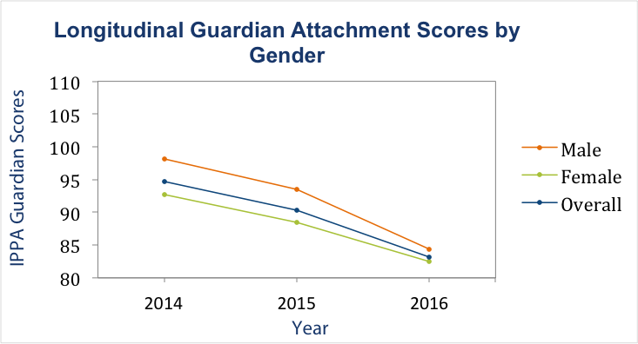Figure 1. Guardian Attachment Scores by Gender. Whole longitudinal sample (n=55; blue) exhibits decreasing guardian attachment (IPPA range is 25 to 125) between 2014 and 2016 (p=0.00). Males (n=20; orange) show slightly higher guardian attachment than females (n=35; green) (p=0.109).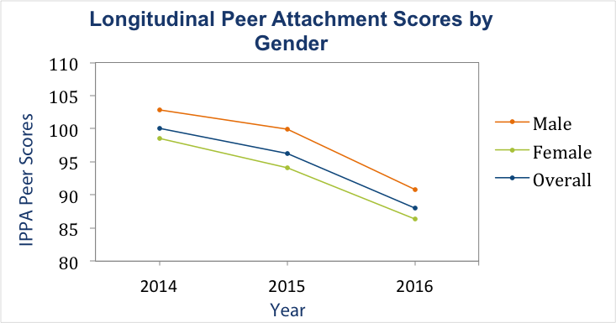Figure 2. Peer Attachment Scores by Gender. Between 2014 and 2016, IPPA Peer attachment scores (range is 25 to 125) reported from the longitudinal sample show a main effect of time (p=0.00). Males (n=20; orange) show higher peer attachment than females (n=35; green) (p=0.058).

Self-Concept: Self-concept scores were measured using the Piers-Harris 2 in 2014, 2015, and 2016. Scores from the longitudinal sample (n=64) increased consistently between 2014 and 2016 (p=0.063). Generally, males in the longitudinal sample consistently had higher mean averages than females in the longitudinal sample during all three years but not significantly so (p=0.148). However, both males’ scores and females’ scores increased from 2014 to 2016.
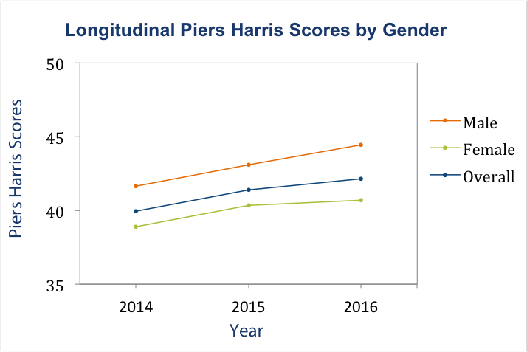Figure 3. Longitudinal Self-Concept Scores by Gender. Combined sample three-year data for longitudinal sample (n=64; blue) shows a general increase in self-concept (p=0.063). Gender differences are not significant (p=0.148).
Trauma-Symptoms: Trauma related symptoms were measured using the Trauma Checklist for Children (TSCC) during all three years of the study. The TSCC assesses the current posttraumatic stress and psychological symptomology of children who have experienced traumatic events such as violence, abuse, major loss, or natural disasters. The TSCC scores are normalized to t-scores, and scores above 65 are considered to reflect significant risk. The longitudinal sample (n=57) was administered the TSCC in 2014, 2015 and 2016. Mean scores during all three years (2014: 42.1, 2015: 40.4, 2016: 43.3) were under the threshold for significant risk and remained fairly uniform. In all three years, males (n=23) performed significantly better than females (n=34) (p=0.038). Gender specific scores diverged significantly between 2015 and 2016, with females displaying an increase in trauma symptoms and males displaying a decrease compared to 2015 (time by gender interaction p=0.029).
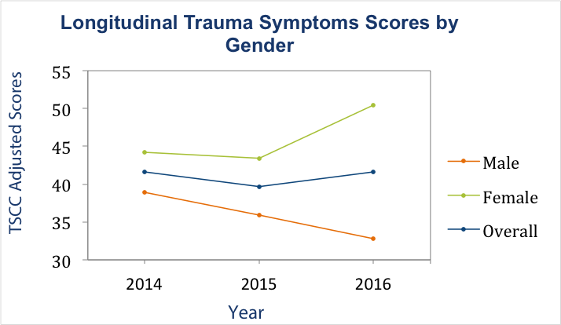Figure 4. Longitudinal TSCC Scores by Gender. In the longitudinal sample, between 2014 and 2016, females (n=34; green) report more trauma symptoms than males (n=23; orange) (p=0.038) and there is a significant time by gender interaction (p=0.029).
Ego-Resiliency: Ego-resiliency was measured using the ER-89 in 2014, 2015, and 2016. The ER-89 scores are graded as follows using tertiles: very high (47-56), high (35-46), undetermined (23-34), low (11-22), and very low (0-10). Overall, the longitudinal sample (n=26) displayed high average ER-89 scores in 2014, 2015, and 2016. When scores were separated across genders, there seemed to be a convergence effect between 2014 and 2015 and a divergence between 2015 and 2016, with females reporting lower mean scores than males in 2014 and 2016. However across the three years there was not a significant difference between male and female levels of ego-resiliency (p=0.382). The pattern highlights the importance of longitudinal collection because year-to-year trends can be volatile but the overall pattern of males showing higher scores over time provides more insight and confidence in interpreting group and individual needs.
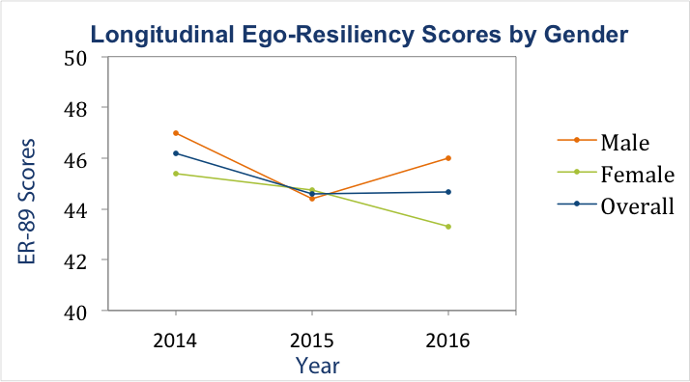Figure 5. Longitudinal Sample Ego-Resiliency Scores by Gender. Overall longitudinal sample (n=26; blue) and both genders are exhibiting above average ego-resiliency (scores > 44) across all three years. Three-year gender differences were not significant (p=0.382).
Depression: In 2016, 92 total children were administered the Epidemiological Studies Depression Scale (CES-DC) in order to measure depression symptoms, and the longitudinal sample participants (n=67) were administered the CES-DC in 2015 and 2016. Children who scored above a 15 on the CESD-C are considered to exhibit depression symptoms and are identified as potentially at risk for clinical depression (CES-DC scale ranges from 0-60). These children are typically referred to mental health professionals for further diagnostic confirmation and potential treatment. The 2016 CESD-C scores ranged from 1-54 with a mean score of 20.74 and median score of 21.06. Additionally, 65 out of 92 participants (70.7%) reported scores above 15. Thus, a significant majority of participants scored above the threshold for risk. However, further examination and professional analysis is needed to diagnose and appropriately provide depression support and clinical services.
In the longitudinal sample (n=67) there was a slight increase in mean CESD-C score between 2015 (20.07) and 2016 (21.39). However, this effect was not significant (p=0.496). Mean scores from the longitudinal sample during both years are above the scale threshold for depression. The longitudinal scores were also separated by gender. Females (n=41) had higher CES-DC scores than males (n=26) in both 2015 and 2016 (males [2015: M=19.1154, SD=13.79; 2016: M=18.65, SD=9.20], females [2015: M=20.68, SD=10.18; 2016: M=23.13, SD=10.07]) but were not statistically different (p=0.133). Moreover, the scores appear to diverge in 2016 (i.e. females’ scores increased from 2015 to 2016 while males’ scores decreased slightly).
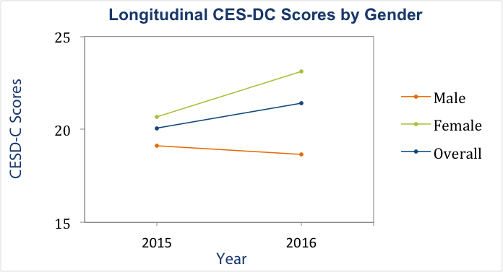Figure 6. Longitudinal Sample CES-DC Scores by Gender. Across both years* females (n=41; green) and males (n=26; orange) in the longitudinal sample showed depressive symptoms (CES-DC scores > 15). Gender scores tend toward divergence, but gender differences are not significant (p=0.216).

Discussion
This longitudinal gender analysis among an OSC population in Delhi, India shows that over three years, females are consistently reporting higher average trauma symptoms, lower attachment, and lower self-concept scores than their male counterparts, though these average differences are not always significant, indicating high variation within gender scores as well. Furthermore, while the CES-DC was only administered in 2015 and 2016, during both years, females reported higher levels of depression than males. These findings suggest that overall males could be outperforming females in mental health outcomes within this residential care environment.
The significance of attachment results is ambiguous. The scores still remain around the norm for the IPPA, and in general, it is natural for children to become less attached to guardians as they age. However, we expected this trend to be paired with increased peer attachment, which is not observed. It has been postulated that high attachment scores actually may represent a compensatory mechanism that arises in children who have experienced difficult backgrounds. In this case, attachment manifests as dependence on others. If this framework is accurate, decreasing attachment scores might actually be positive and could represent a natural transition of maturing.
Gender differences in trauma outcomes may be attributed to differences in internalizing trauma (Goldenson, Geffner, Foster, & Clipson 2007) possibly leading to lower coping behaviors. Females may have initially internalized their traumatic experiences, not facing the mental health ramifications of their past until they reach adolescence. Interestingly, males reported a higher level of peer and guardian attachment, a construct thought to be a protective factor against internalizing trauma.
It is important to note that aside from trauma, none of the gender differences were significantly different. For example, ego-resiliency for both genders across all three years is graded as high on the ER-89 (slight fluctuations may be attributable to normal development patterns). Additionally, both males and females report average scores above the clinical threshold for depressive symptoms.
Our findings thus far tend to support prior studies conducted within OSC populations in LMIC showing female and male mental health to be comparable (Gray et al. 2015). Therefore, it will be important to increase systems of mental health support for both males and females, while taking into consideration gender-based variations for specific mental health constructs such as trauma.
Overall, our results are far more promising than our initial expectations. Both males and females within the longitudinal sample are performing comparably to non-OSC counterparts on all of our measures except for depression and trauma. Accordingly, these data could indicate support for notion that children residing with our organizational partner, Udayan Care, are having success in staying at relatively healthy mental health levels and possibly counteracting some of the mental health detriments associated with OSC populations. Further longitudinal examination of this sample, along with time and past-history based controls will help confirm changes in children’s mental health outcomes and assess the stability of current gender-varied trends.
Because our sample was obtained primarily from group homes within a single organization, it would be difficult to generalize the results of our analysis to the wider population of OSC in India. An expansion of the current mental health literature in India would be invaluable in measuring the results from our partner organization against peer organizations or controlled norms. Mental health awareness in general must be improved in India, especially in the context of OSC, in order to validate the given results and devise solutions for this and other vulnerable populations.

Methods
Participants: Children across 11 residential care homes were interviewed on various mental health outcomes in the summers of 2014, 2015, and 2016. In 2014, 89 children were randomly sampled from 11 residential care homes (ghars) within Delhi, India based on gender and age characteristics. All children ages 4-8 within the homes were included in the study to have an equal number of participants from each of the three age groups (ages: 4-8, 9-14, and 15-18). Additionally, since 7 of the 11 group homes are female, children were sampled to reflect the overall gender proportions enrolled in the residential home program. The 2016 sample of children (n=95) consisted of 65 children who were previously interviewed both in 2014 and 2015. Furthermore in 2015 an additional mental health construct was assessed, depression. 66 children answered depression related questions in both 2015 and 2016.
Measures: Children were assessed on five mental health constructs—attachment, self-concept, ego resiliency, trauma, and depression—during one-on-one interviews. Inventory of Parent and Peer Attachment (IPPA), Piers-Harris Children’s Self-Concept Scale (PH2), Trauma Symptoms Checklist for Children (TSCC), Ego-Resiliency Scale (ER-89), and Center for Epidemiological Studies Depression Scale (CES-DC) were chosen for their cross-cultural validity or extensive use within the United States. All measures were translated and back translated prior to use for reliability purposes.
Data Analysis: All data analysis was conducted using IBM SPSS Statistics software and Microsoft Excel. In the case of three-year and two-year data, factorial within-subjects ANOVA were used to test for significance (p < 0.05). Raw scores from the Piers-Harris Children’s Self-Concept Scale and Trauma Symptoms Checklist for Children were converted into normalized t-scores for analysis.

References
- Ainsworth, M.D.S., Blehar, M.C., Waters, E., & Wall, S. (1978). Patterns of attachment: A psychological study of the strange situation. Hillsdale, NJ: Lawrence Erlbaum.
- Alessandri, G., Barbaraneilli, C., Gerbino, M., & Vecchione , M. (2010). Stability and change of ego resiliency from late adolescence to young adulthood: A multi perspective study using the er89-r scale. Journal of Personality Assessment, 92(3), 212-221.
- Baumeister, R. F. (Ed.). (1999). The self in social psychology. Psychology Press.
- Belsey, Mark A., and Lorraine Sherr. (2011). The Definition Of True Orphan Prevalence: Trends, Contexts And Implications For Policies And Programmes. Vulnerable Children and Youth Studies 6.3 , 185-200.Bryne, B (1986). On the structure of adolescent self-concept. Journal of Educational Psychology, 78, 474-481.
- Bowlby, J. (1969/1982). Attachment and Loss: Vol. 1. Attachment (2nd). New York: Basic Books.
- Bryne, B (1986). On the structure of adolescent self-concept. Journal of Educational Psychology, 78, 474-481.
- Chapman, J. (1990). Some antecedents of academic self-concept: A longitudinal study,The British Psychological Society, 60, 142-152.
- Ding, H., Han, J., Zhang, M., Wang, K., Gong, J., & Yang, S. (2017). Moderating and mediating effects of resilience between childhood trauma and depressive symptoms in Chinese children. Journal of Affective Disorders, 211, 130–135.
- Dozier, M., Zeanah, C.H., Wallin, A.R., & Shauffer, C. (2011). Institutional care for young children: review of literature and policy implications. Social Issues and Policy Review, 6(1), 1-25.
- Dwyer, K. M., B. K. Fredstrom, K. H. Rubin, C. Booth-Laforce, L. Rose-Krasnor, and K. B. Burgess. (2010). Attachment, Social Information Processing, and Friendship Quality of Early Adolescent Girls and Boys. Journal of Social and Personal Relationships, 91-116.
- Goldenson, J., Geffner, R., Foster, S. L., & Clipson, C. R. (2007). Female domestic violence offenders: their attachment security, trauma symptoms, and personality organizations.
- Gray, C. L., Pence, B. W., Ostermann, J., Whetten, R. A., O’Donnell, K., Thielman, N. M., & Whetten, K. (2015). Gender (in) differences in prevalence and incidence of traumatic experiences among orphaned and separated children living in five low- and middle-income countries. Global Mental Health, 2.
- Keller (2013). Attachment and culture. Journal of Cross-Cultural Psychology, 44(2), p. 175-194.
- Li X, Barnett D, Fang X, Lin X, Zhao G, Zhao J, Hong Y, Zhang L, Naar-King S, Stanton B. (2009). Lifetime incidences of traumatic events and mental health among children affected by HIV/AIDS in rural China.Journal of Clinical Child & Adolescent Psychology, 38, 731–744.
- Main, M. (2000). The organized categories of infant, child and adult attachment. Journal of the American Psychoanalytic Association, 48, 1055-1095.
- Rubin, K. H. “Attachment, Friendship, And Psychosocial Functioning In Early Adolescence.” The Journal of Early Adolescence (2004): 326-56
- van IJzendoorn, M. H., & Kroonenberg, P. M. (1988). Cross-cultural patterns of attachment: A meta-analysis of the strange situation. Child Development, 59, 147-156.
- van IJzendoorn, M.H., Palacios, J., Sonuga-Barke, E.J.S., Gunnar, M., Vorria, P., McCall, R.B., LeMare, L., Bakermans-Kranenburg, M.J., Dobrova-Krol, N.A., & Juffer, F. (2011). Children in institutional care: delayed development and resilience. Monogr Soc Res Child Dev, 76(4), 8-30.
- Whetten, K., Ostermann, J., Whetten, R., O’Donnell, K., Thielman, N. and The Positive Outcomes for Orphans Research Team (2011), More than the loss of a parent: Potentially traumatic events among orphaned and abandoned children. Traum. Stress, 24: 174–182.
- Whetten, K., Ostermann, J., Whetten, R., Pence, B., O’donnell K., Messer L., Thielman. N.(2009). A comparison of the wellbeing of orphans and abandoned children ages 6–12 in institutional and community-based care settings in 5 less wealthy nations.PLoS ONE.
- Wingo, A. P., Wrenn, G., Pelletier, T., Gutman, A. R., Bradley, B., & Ressler, K. J. (2010). Moderating effects of resilience on depression in individuals with a history of childhood abuse or trauma exposure. Journal of Affective Disorders, 126(3), 411–414.

Acknowledgements
This research was supported by the Duke Global Health Institute Student Research Training Program. We thank our faculty mentor Dr. Sumedha Ariely for her indispensable guidance and support. We would also like to thank our community partners Dr. Kiran Modi and Dr. Monisha Nayar-Akhtar for their partnership, backing of our work on the ground, and thoughtful advice. We would like to acknowledge all the Udayan staff for their passion and determination to provide a better future for the Udayan children. Lastly, we are grateful for 2014 and 2015 Duke Student Research Training Program (SRTP) India Teams for collecting 2 years of data that were used for our analysis.

